PM3 CLASS EXERCISE 04/05/2022 (Groups 3A ,B, C, D, E, F, G, and K)
Consider the scenario below and answer the questions that follows.
After consultation with the stakeholders of a small business regarding the development of an in-house system, the project manager presented the work breakdown structure for the project.
The tasks are listed along with the estimated duration. However, whatever the network diagram indicates, the project must finish in 50 days to complete in time for the upcoming holidays.
Activity |  | Predecessors | Duration in days
A | Define Integration | None | 10
B | Code API s | A | 25
C | Purchase Components | A | 5
D | Systems Testing | B and C | 12
E | Writing User Manuals | A | 20
F | Systems Training | E and D | 4
G | System Implementation | F | 10

Required:
Perform a forward and back pass to calculate the early start (ES), early finish (EF), late start (LS), late finish (LF) and calculate the float/slack for each activity.

The components of the network diagram are presented in the diagram below. Draw/Complete and connect the activities together in the correct sequence of predecessor and successor. Representing all elements of the activities in the network diagram. Use this to calculate the forward and back pass

Use the answer sheet format provided.
 |  |  | ACTIVITY | Days | ES | EF | LS | LF | SLACK
 | A |  | Define Integration | 10 | 0 | 10
 | B |  | Code API s | 25 | 10 | 35
 | C |  | Purchase Components | 5
 | D |  | Systems Testing | 12
 | E |  | Writing User Manuals | 20
 | F |  | Systems Training | 4
 | G |  | System Implementation | 10 |  |  |  | 60
ALL answers and diagram must be uploaded after lecture before the end of the day.
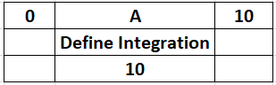
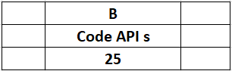
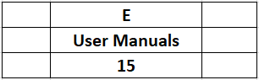
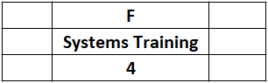
20
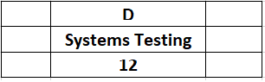

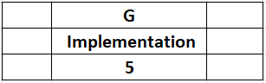
;;

10

